Five College Coastal and Marine Sciences
Independent Research Project Proposal Form

This form must be completed by the student and signed by the FCCMS faculty advisor. Ideally, it is completed and approved prior to/at the beginning of the research project.
**Please complete and submit this form by October 15th of your senior year.**

Student Name: | Graduation Month/Year:
Email: | Institution:
Phone: | Local Address:
Major/minor: | FCCMS Program Advisor:
Project Mentor:  Email: | Project Topic:

Describe your proposed research project, providing details as they are available.

RESEARCH LOCATION:
RESEARCH MENTOR:
SYSTEM OR ORGANISM BEING STUDIED:
HYPOTHESIS:
PREDICTION:
APPROACH AND METHODS:

I approve of this marine-related research project and agree to meet with this student to provide feedback on the project as it progresses (prior to poster completion and the spring poster session):

FCCMS Program Advisor Name (please print) ____________________________
Advisor Signature ___________________________________Date____________
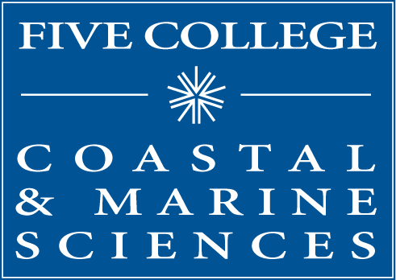
Five College Coastal and Marine Sciences
97 Spring Street
Amherst, MA 01002
(413) 542-4024
marinesci@fivecolleges.edu
www.fivecolleges.edu/marine

