Five College Coastal and Marine Sciences
Independent Research Project Proposal Form

This form must be completed by the student and signed by the FCCMS faculty advisor before research is completed.
**This form must be submitted with your certificate application submission.**

Student Name: | Graduation Month/Year:
Email: | Institution:
Phone: | Local Address:
Major/minor: | FCCMS Program Advisor:
Project Mentor:  Email: | Project Topic:

Describe your proposed research project, providing details as they are available.

RESEARCH LOCATION:
RESEARCH MENTOR:
SYSTEM OR ORGANISM BEING STUDIED:
HYPOTHESIS:
PREDICTION:
APPROACH AND METHODS:

I approve of this marine-related research project and agree to meet with this student to provide feedback on the project as it progresses (prior to its submission to the Steering Committee for certificate approval):

FCCMS Program Advisor Name (please print) ____________________________
Advisor Signature ___________________________________Date____________
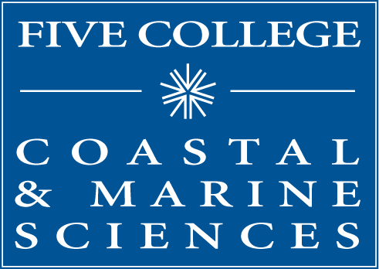
Five College Coastal and Marine Sciences
97 Spring Street
Amherst, MA 01002
(413) 542-4024
marinesci@fivecolleges.edu
www.fivecolleges.edu/marine

